Day 23 - 104608492 - Shirisha Perapagu

JUnit Practice and Creational Design Patterns

Task01

@Tag Annotation

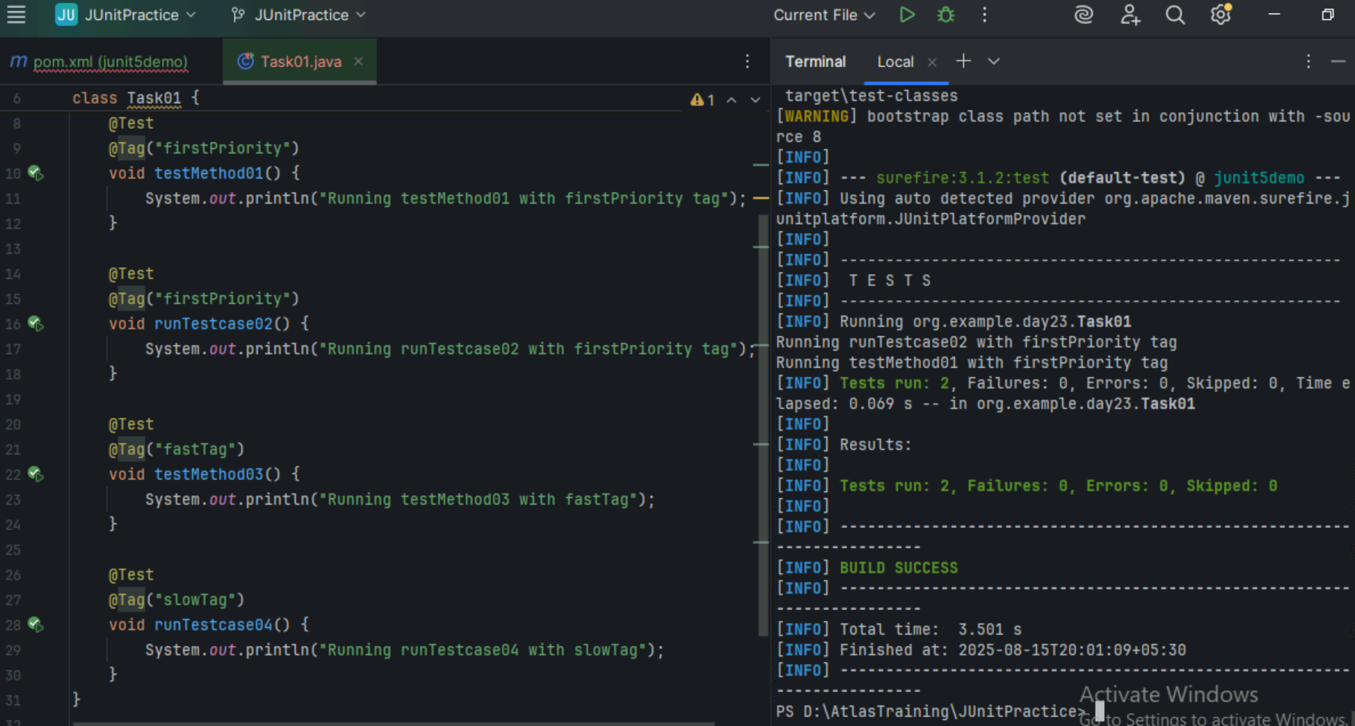

Task 02

Design Patterns

* Creational Design Patterns
  1. Factory Method
  2. Singleton
  3. Abstract Factory
  4. Builder
  5. Prototype

1. Task02 - Factory DP – Creating PepperoniPizza

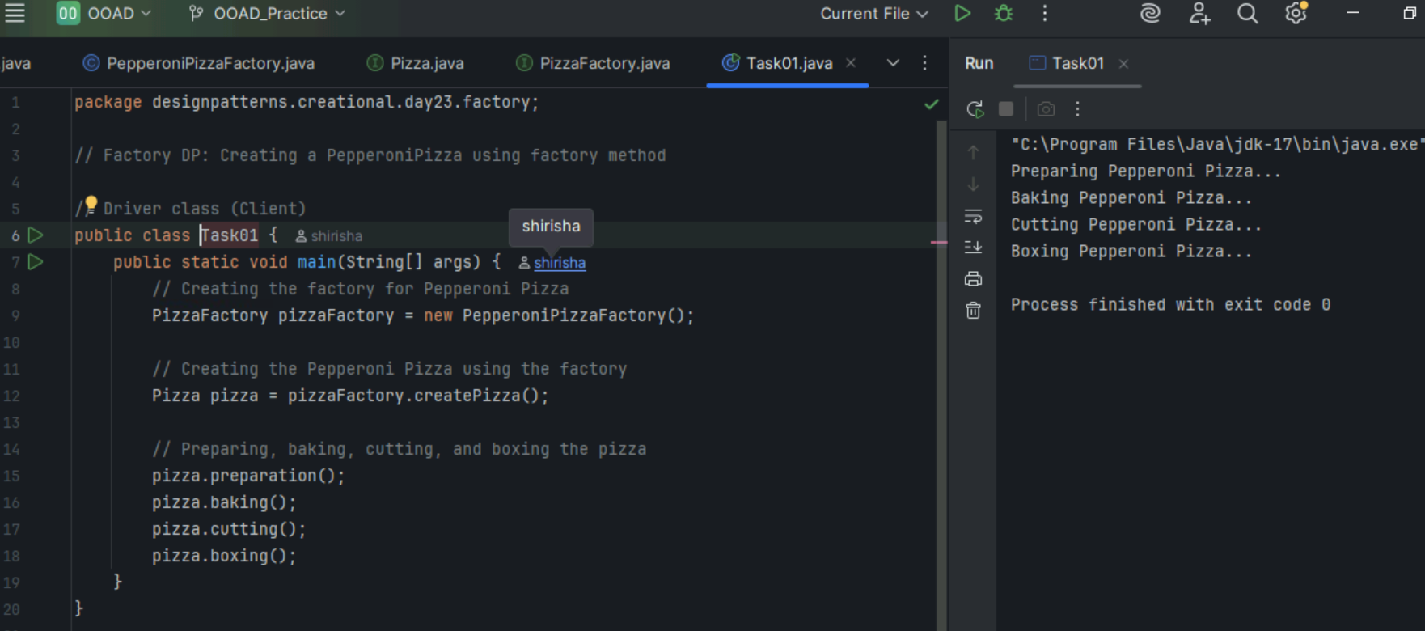

1. Task 03 – Singleton DP

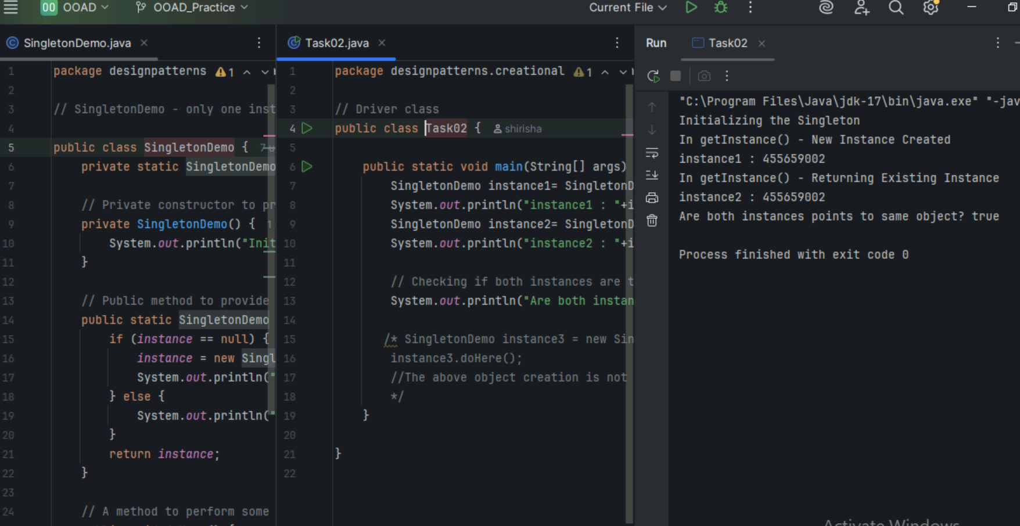

=========================================================================

Home Tasks

=========================================================================

Task04

Main Java class : Task04.java

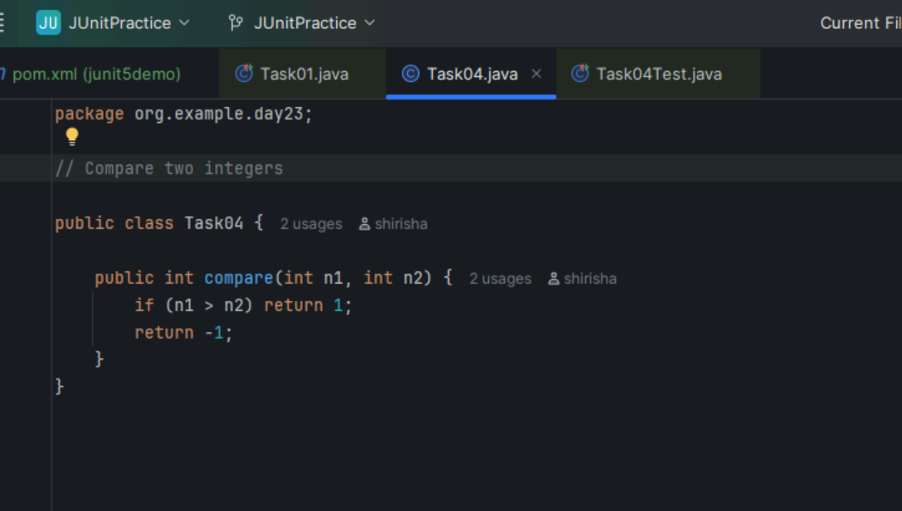

Test Class : Task04Test.java

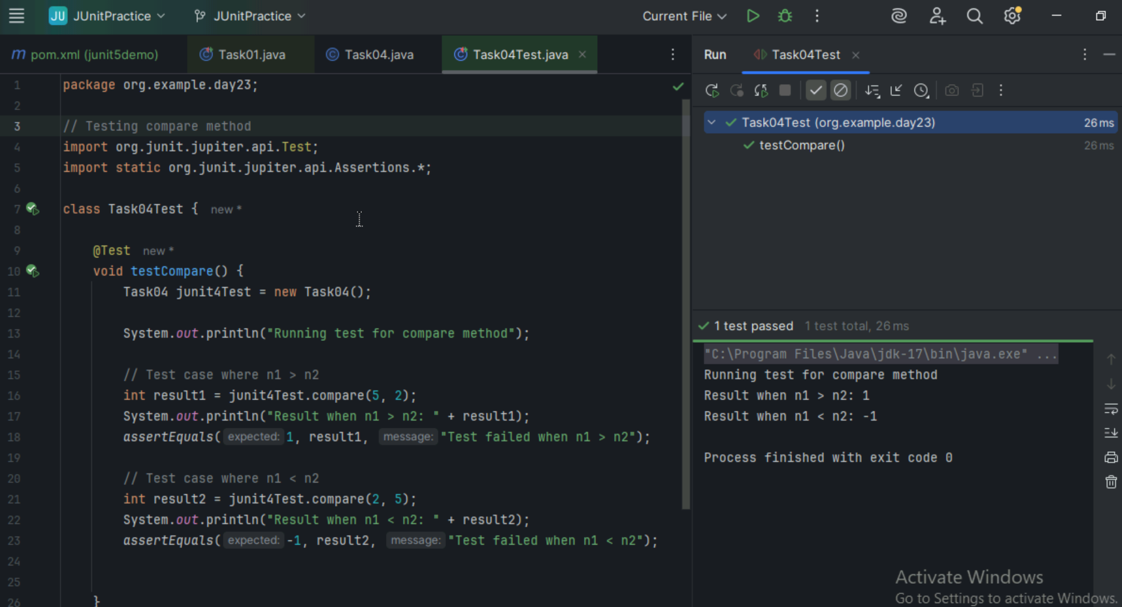

Task05

Suite example 2

MessageUtil class

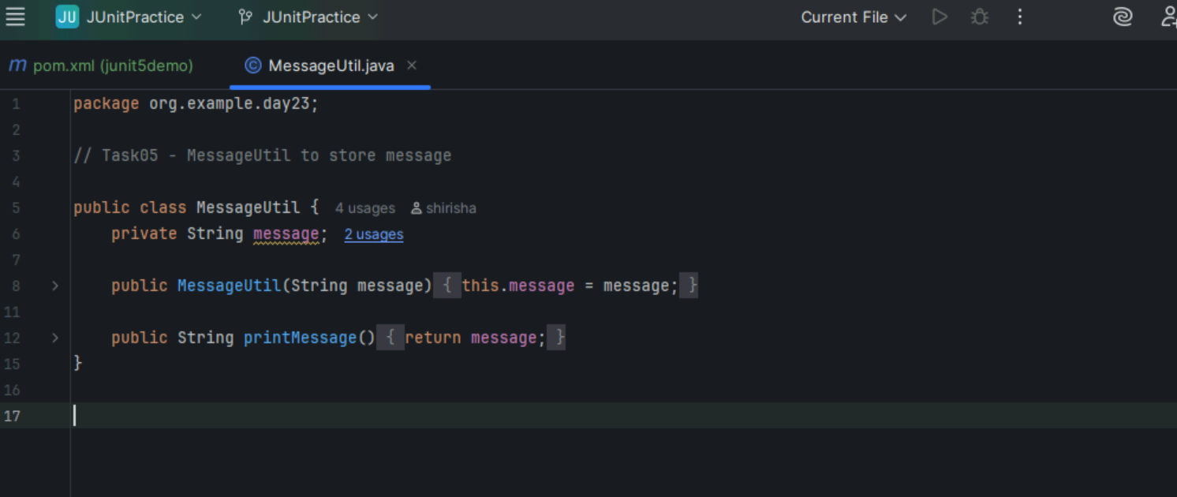

Task05 TestCase1

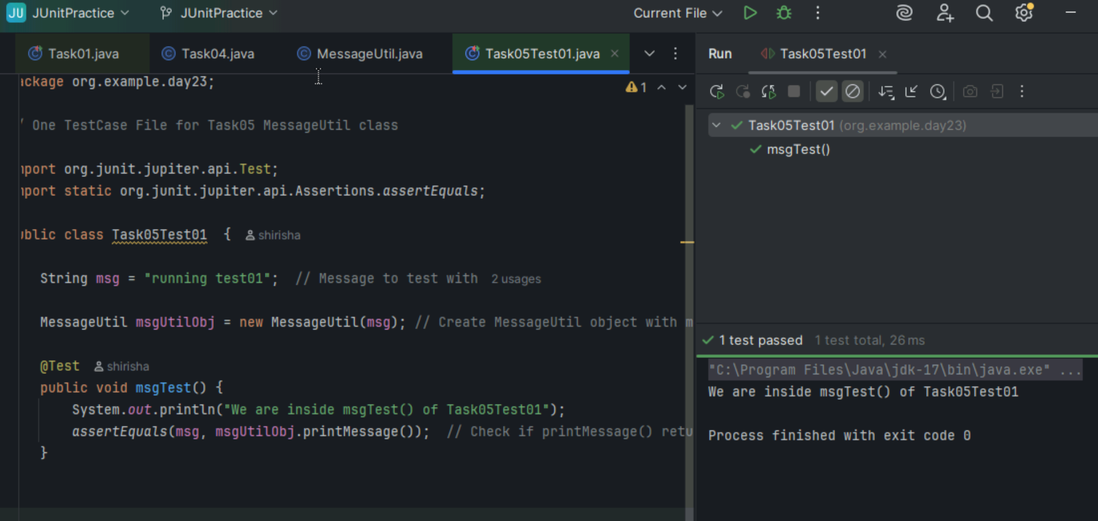

Task05 TestCase2

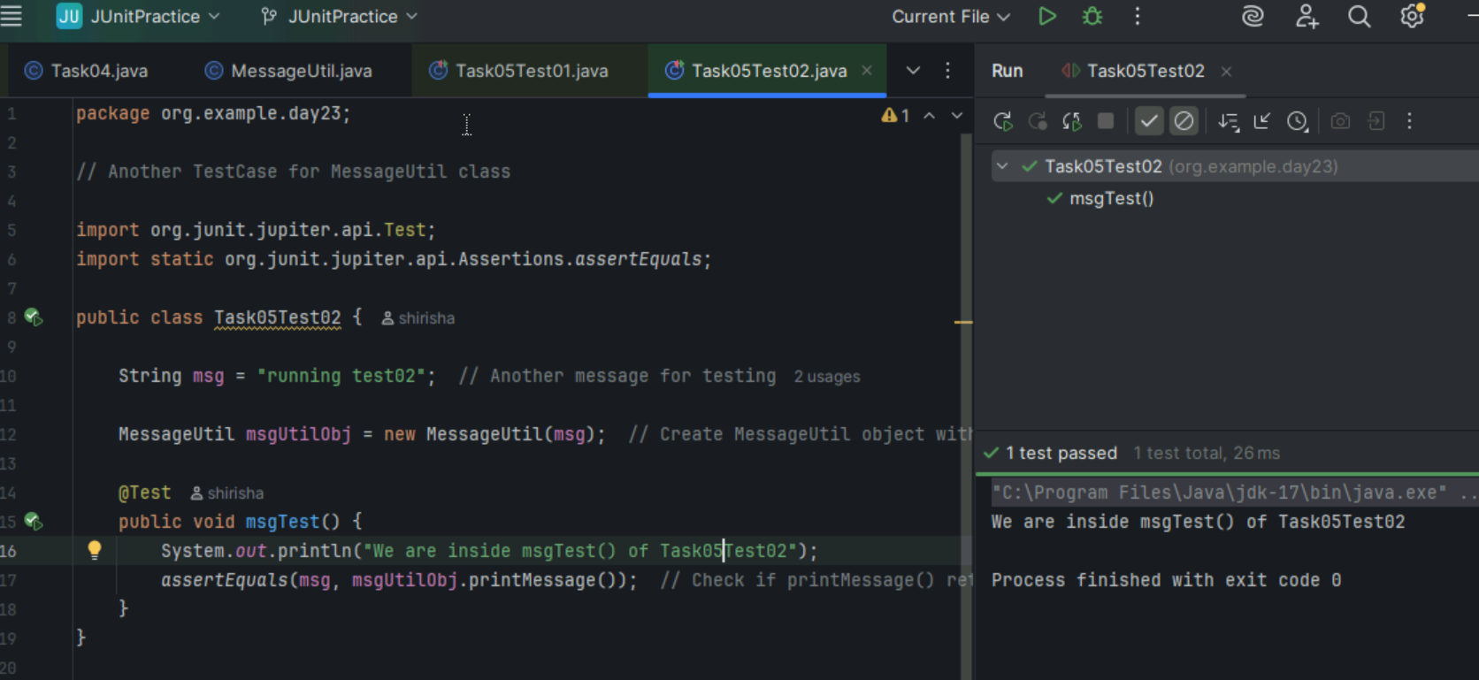

Task05Runner – to run the suite

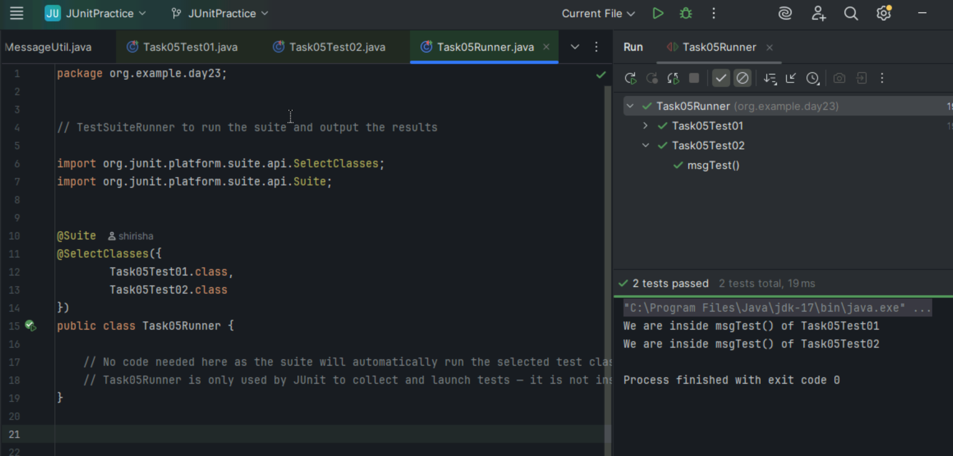

Task 06

Add one more testcase for above code and execute it.

Task06Test.class – one more Testclass

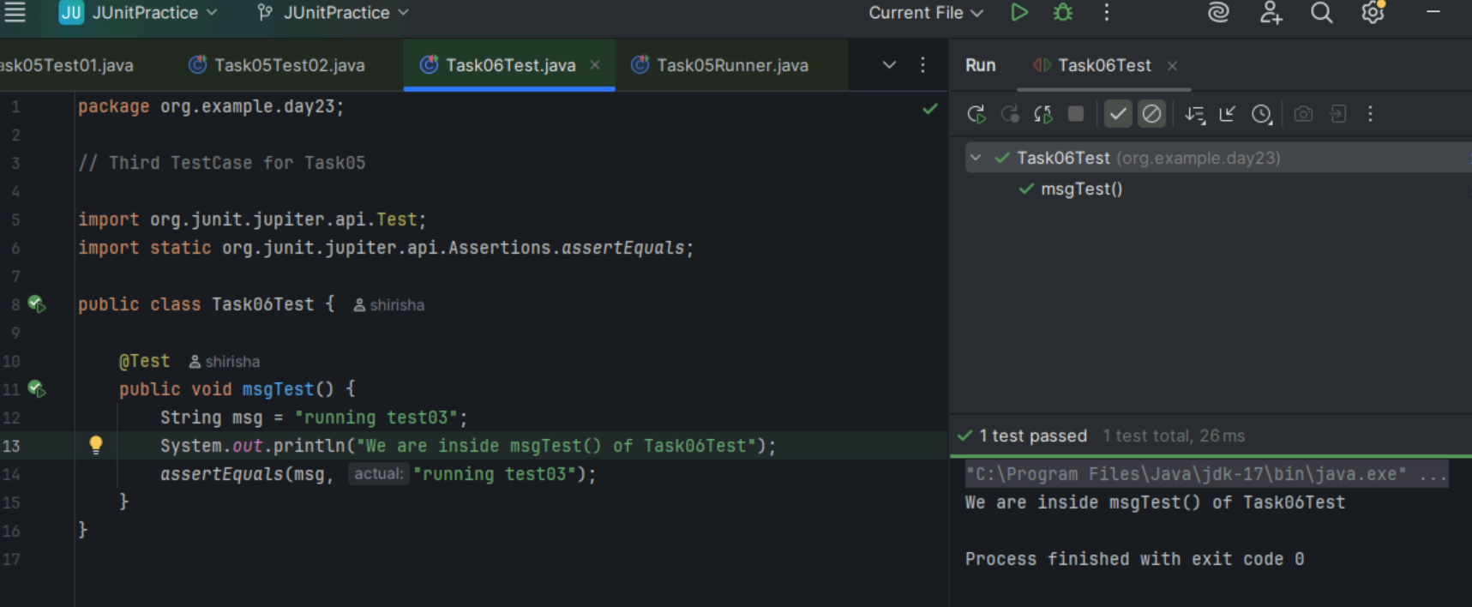

Updated Task05Runner

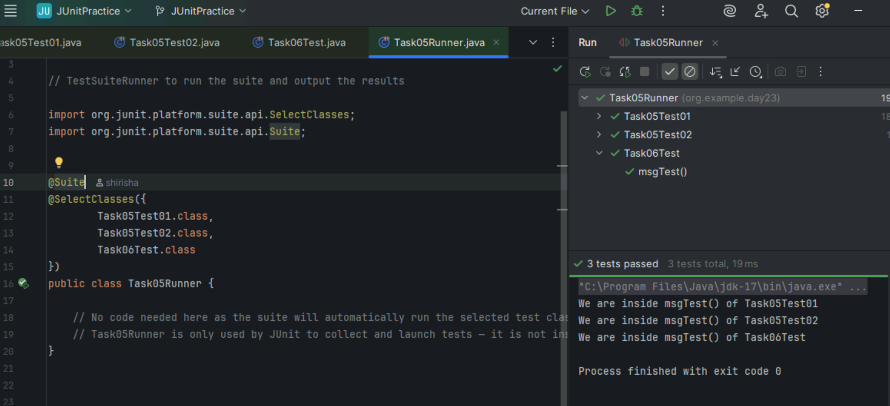

Task 07 : UML diagram

@startuml

    participant Pax as p

    actor “Actor” as a #Green

    boundary “Boundary” as b

    control C as c

    database Dbase as db

    entity table as t

    collections col as c

    queue que as q

    autonumber

    p -[#red]> a : pax to actor

    a ->x p: ohh is it!

    autonumber 100

    b ->> p: boundary to pax

    note left: plz make a note on left

    c -\ p: control to pax

    db \\- p: db to pax

    autonumber 50 10

    t //-- db: table to db

    c ->o db: collection to db

    note right: plz make a note

    q <->o p: q to pax

Trainer -> p : instruct Pax

p -> Batch2 : forward to Batch2

    Trainer -> Batch2 : learning uml

    Batch2 -> Trainer: ok will learn

@enduml

